A.1
CREATE TABLE StudentResult (
StudentID INT PRIMARY KEY,
StudentName VARCHAR(50),
Course VARCHAR(30),
City VARCHAR(30),
Marks INT,
FeesPaid DECIMAL(10,2)
);

INSERT INTO StudentResult
(StudentID, StudentName, Course, City, Marks, FeesPaid)
VALUES
(1, 'Amit Sharma', 'BCA', 'Pune', 85, 45000.00),
(2, 'Priya Patel', 'BCA', 'Mumbai', 92, 48000.00),
(3, 'Rahul Verma', 'BSc IT', 'Pune', 76, 42000.00),
(4, 'Neha Singh', 'BCA', 'Nashik', 88, 45000.00),
(5, 'Rohan Mehta', 'BSc IT', 'Mumbai', 69, 40000.00),
(6, 'Sneha Joshi', 'BCA', 'Nagpur', 95, 50000.00),
(7, 'Karan Shah', 'BSc CS', 'Pune', 81, 43000.00),
(8, 'Pooja Desai', 'BSc CS', 'Surat', 73, 41000.00),
(9, 'Vikas Kumar', 'BCA', 'Delhi', 64, 39000.00),
(10, 'Anjali Rao', 'BSc IT', 'Bangalore', 90, 47000.00);


A.2
-- 1. Total number of students
SELECT COUNT(*) AS TotalStudents
FROM StudentResult;
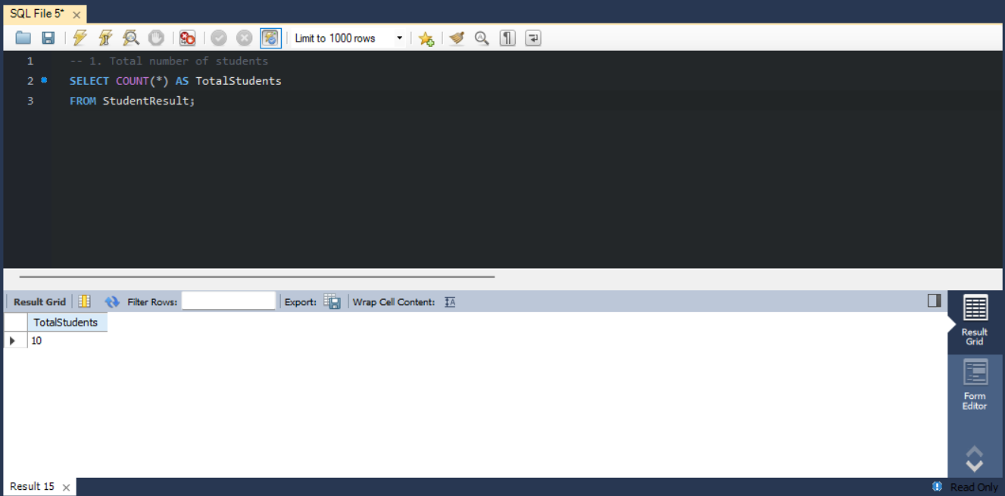

-- 2. Total fees paid
SELECT SUM(FeesPaid) AS TotalFeesPaid
FROM StudentResult;
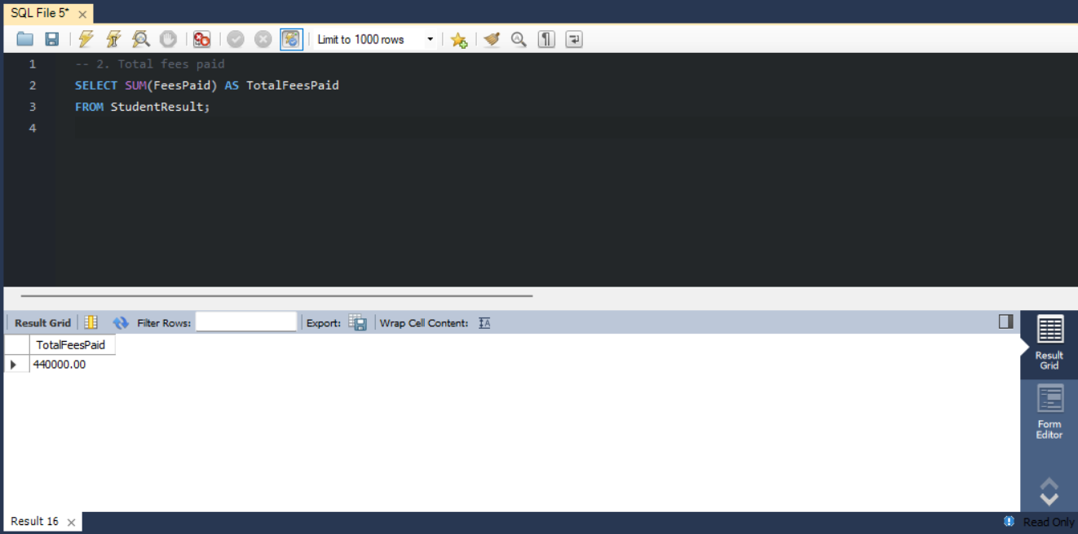

-- 3. Average marks
SELECT AVG(Marks) AS AverageMarks
FROM StudentResult;


-- 4. Lowest marks
SELECT MIN(Marks) AS LowestMarks
FROM StudentResult;


-- 5. Highest marks
SELECT MAX(Marks) AS HighestMarks
FROM StudentResult;
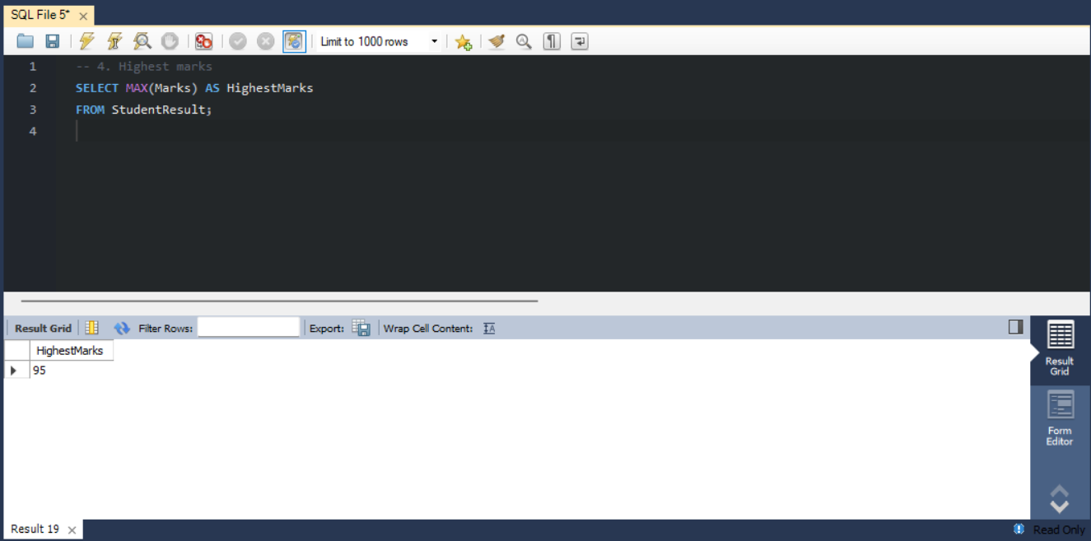

A.3
SELECT Course, COUNT(*) AS TotalStudents
FROM StudentResult
GROUP BY Course;


A.4
SELECT Course, AVG(Marks) AS AverageMarks
FROM StudentResult
GROUP BY Course;
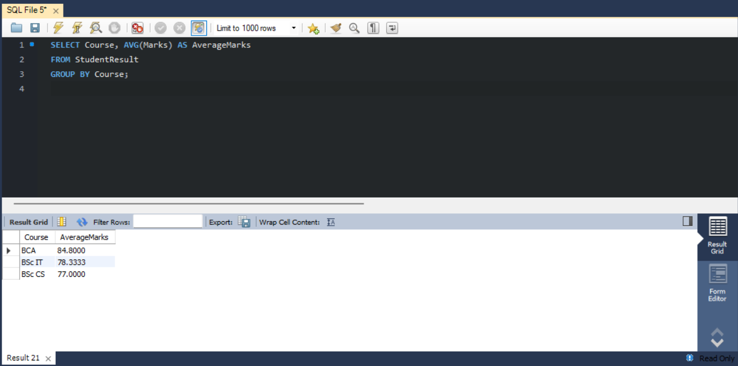

A.5
SELECT Course, COUNT(*) AS TotalStudents
FROM StudentResult
GROUP BY Course
HAVING COUNT(*) > 2;
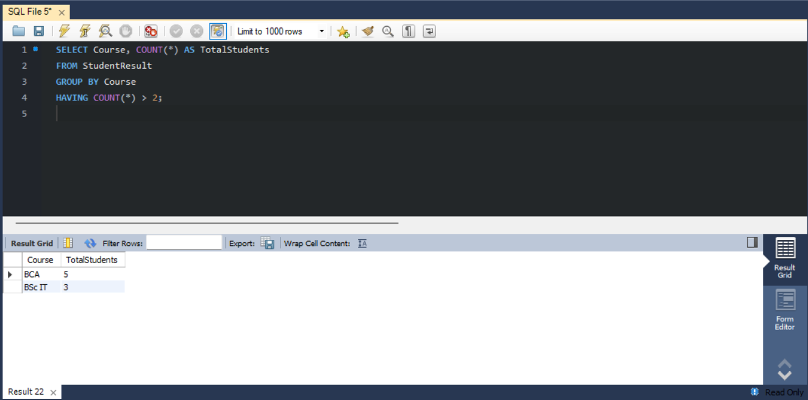

A.6
SELECT
Course,
COUNT(*) AS TotalStudents,
AVG(Marks) AS AverageMarks,
MIN(Marks) AS LowestMarks,
MAX(Marks) AS HighestMarks
FROM StudentResult
GROUP BY Course
ORDER BY AverageMarks DESC;
